**NAME: GENOVIYA.D**

**CLG:ST.JOSEPH COLLEGE OF ENGINEERING**

**CLG CODE:2129**

**REG NO:212921106019**

**WATER QUALITY ANALYSIS**

**INTRODUCTION:**

Water quality refers to the physical, chemical, biological, and radiological characteristics of water, which determine its suitability for various uses, such as drinking, swimming, industrial processes, or ecological health. It encompasses factors like clarity, temperature, pH, dissolved oxygen, pollutants, and contaminants present in the water. Monitoring and maintaining water quality are crucial for human health, environmental conservation, and sustainable development.

**DESIGN THINKING:**

1. Observation-inspiration: an ethnographic survey is conducted, while demonstrating empathy for the people affected

by the issue (the users), as well as for the problem they are experiencing. Users are observed daily to gain insight

into their aspirations and needs.

2. Definition-synthesis: the problem is thoroughly defined and redefined through an iterative process. The goal is to

learn information and gain insight into various perspectives surrounding the issue. The information is briefly

summarised in order to present the problem succinctly. This visualisation of the concepts involved directs the

problem solvers towards a common mutually understood goal.

3. Ideation: many ideas are proposed and some of them are retained, while others are discarded.

4. Prototyping: prototypes are quickly built to emphasise the different ideas that have been generated, and these

prototypes are shared with others in order to assess their implementation potential.

5. Tests: prototypes are evaluated by collecting opinions from users as well as experts on the problem at hand and

winning prototypes are then refined .

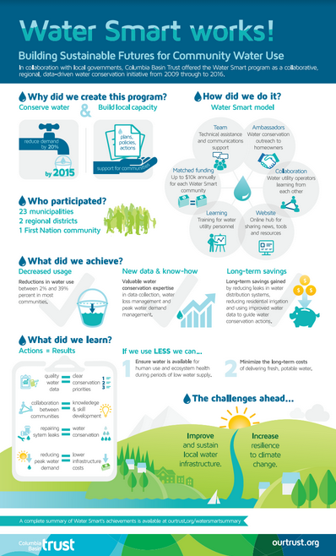

**CONCLUSION:**

The lessons learned from this intrinsic case study can be applied to engineering education in general, offering insight into design thinking as an alternative approach to solving environmental problems, as well as other problems related to civil engineering. As shown by the study results, engineering students who use design thinking to solve environmental problems can find it challenging to collect the users’ input during the problem-solving process (e.g. interviewing users, travelling to multiple users’ homes, etc); however, these same students also revealed that they found the solutions generated from the users’ concerns and needs were more diverse (even giving way to non-technical solution ideas), more imaginative and more feasible.